**Experiment 9**

**Student Name:** Sahil Kaundal **UID:** 21BCS8197

**Branch:** BE CSE (Lateral Entry) **Section/Group:** 807/B

**Semester:** 4th **Date of Performance:** 26/04/2022

**Subject Name:** MPI Lab **Subject Code:** 22E-20CSP-253

1. **Aim/Overview of the practical:**

* Find the smaller out of two numbers.
* Find the larger out of two numbers.

**2. Task to be done/ Which logistics used:**

* Find the smaller out of two numbers.
* Find the larger out of two numbers.

**3. Apparatus / Simulator Used:**

1. Jubin Application

2. 8085 Simulator

3. JDK

**4. Algorithms/Flowcharts:**

1. Find the smaller out of two numbers.
2. Load the content from memory location
3. Move content of Accumulator into Register B
4. Load the content from Memory location
5. Compare the content of Register B
6. If carry flag is equal to 1 go to step 7
7. Move content of Register B into Accumulator
8. Store the content into Memory
9. End of program
10. Find the larger out of two numbers.
11. Load value in the accumulator
12. Then, copy the value to any of the register
13. Load next value in the accumulator
14. Compare both values
15. Check carry flag, if reset then jump to the required address to store the value
16. Copy the result in the accumulator
17. Store the result at the required address
18. End of program

**5. Programs:**

1. Find the smaller out of two numbers.

# BEGIN 000H

LXI H,3000

MOV A,M

INX H

MOV B,M

CMP B

JC 200B

MOV A,B

INX H

MOV M,A

HLT

# ORG 3000H

# DB 54H,38H

1. Find the larger out of two numbers.

# BEGIN 2050H

LDA 2050

MOV B,A

LDA 2051

CMP B

JNC 200C

MOV A,B

STA 3050

HLT

# ORG 2050H

# DB 45H,37H

**6. Result/Output/Writing Summary:**

1. Find the smaller out of two numbers.

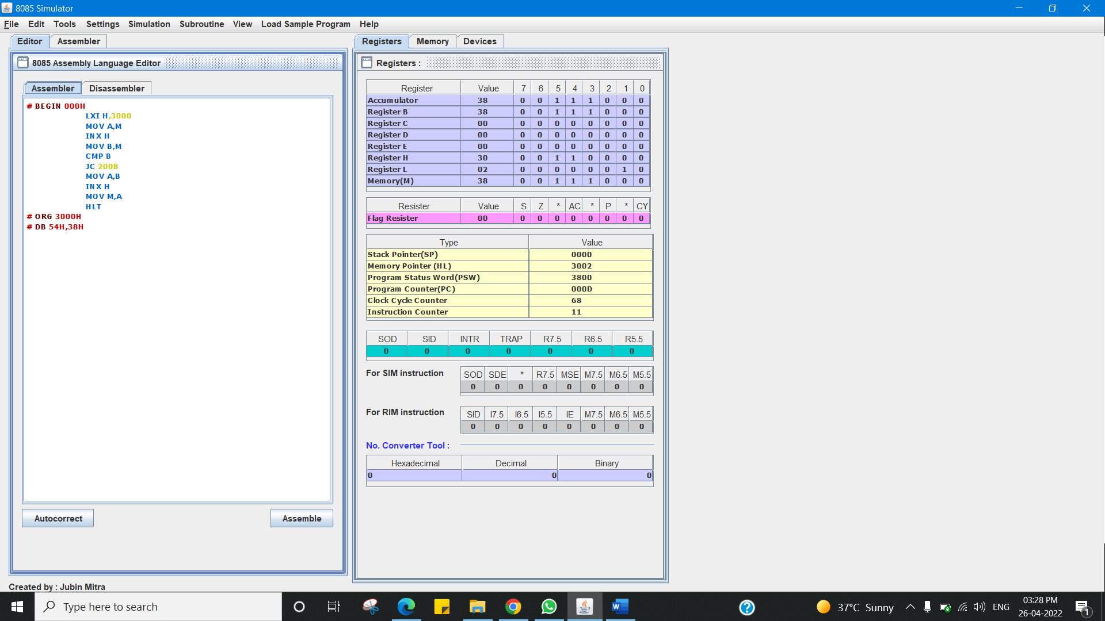

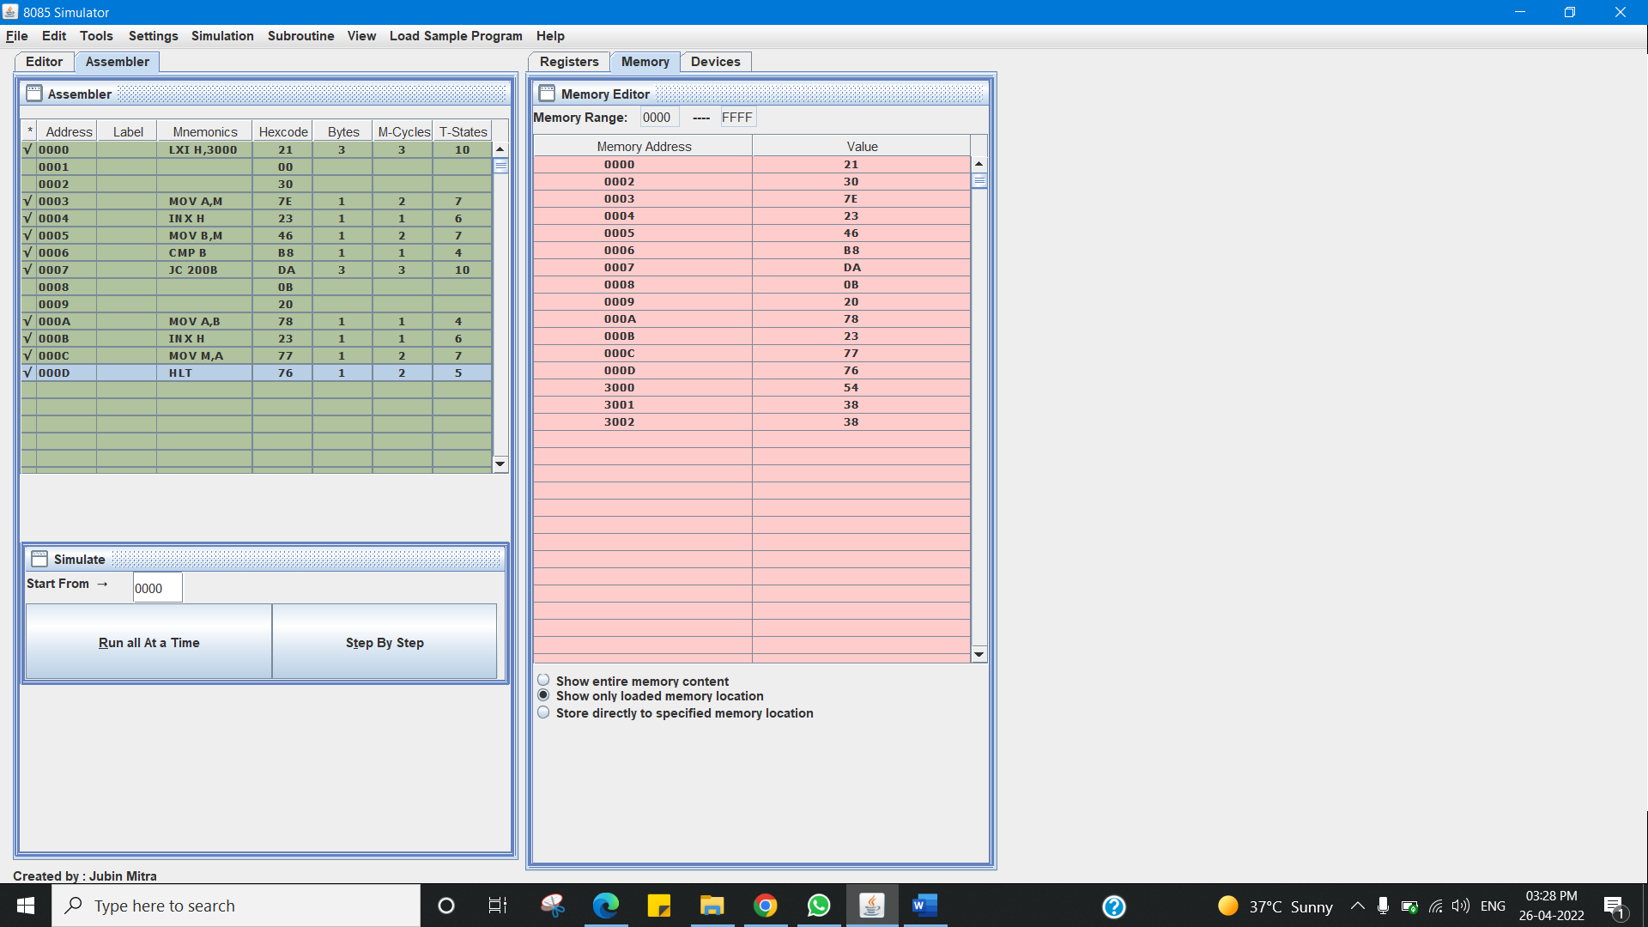

1. Find the larger out of two numbers.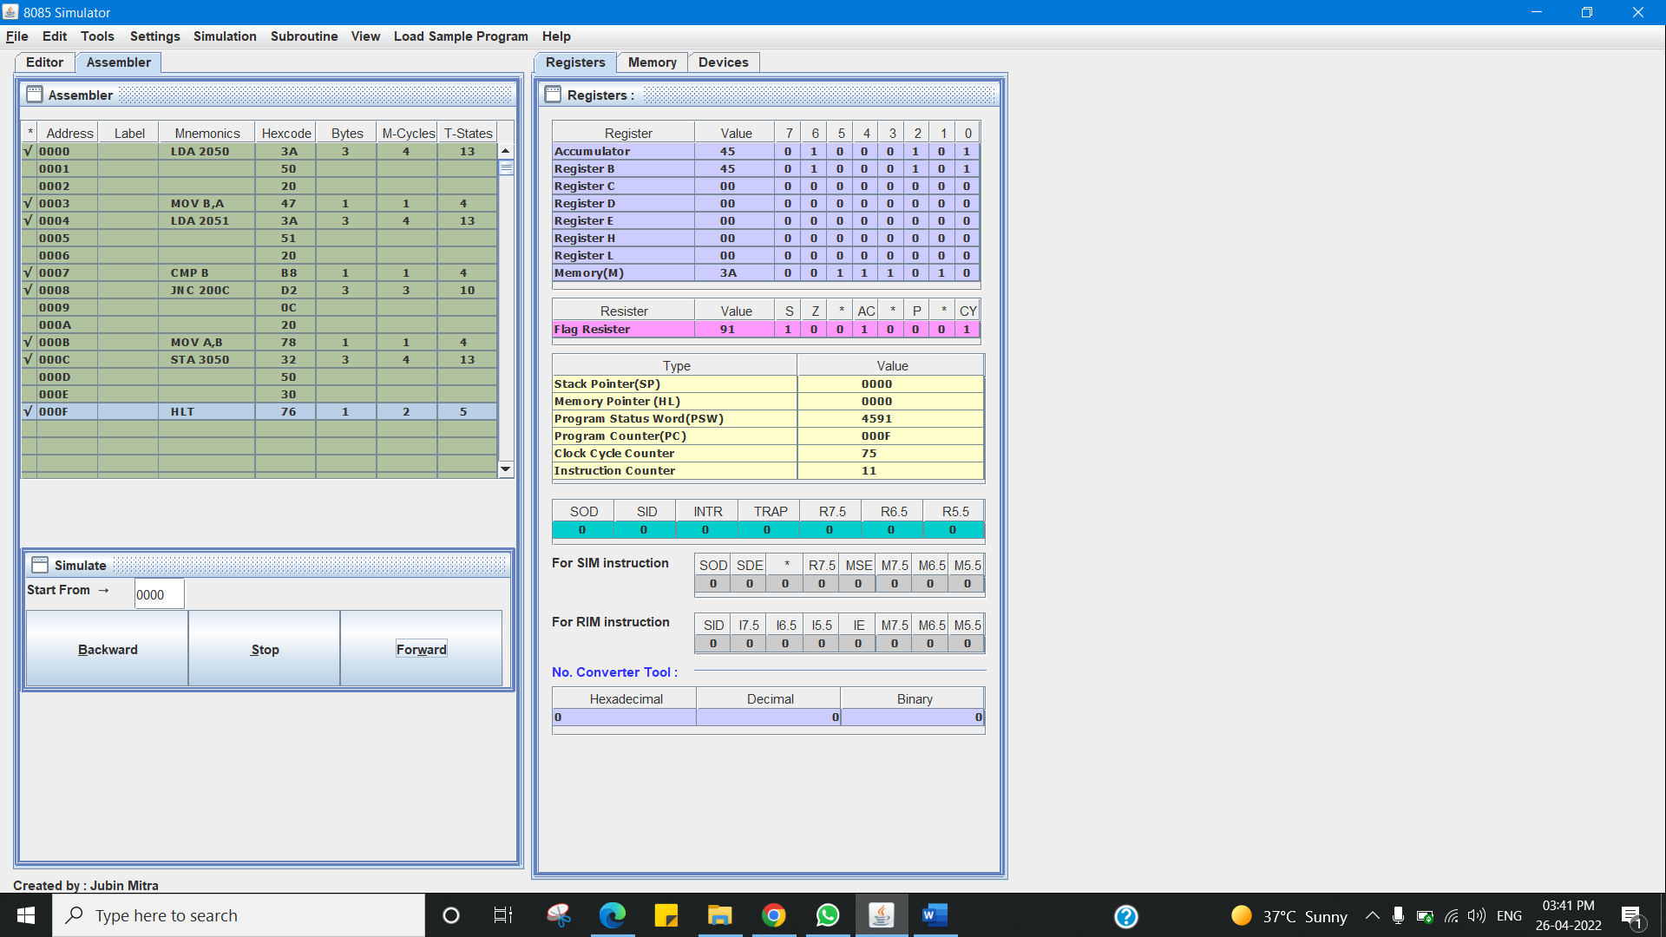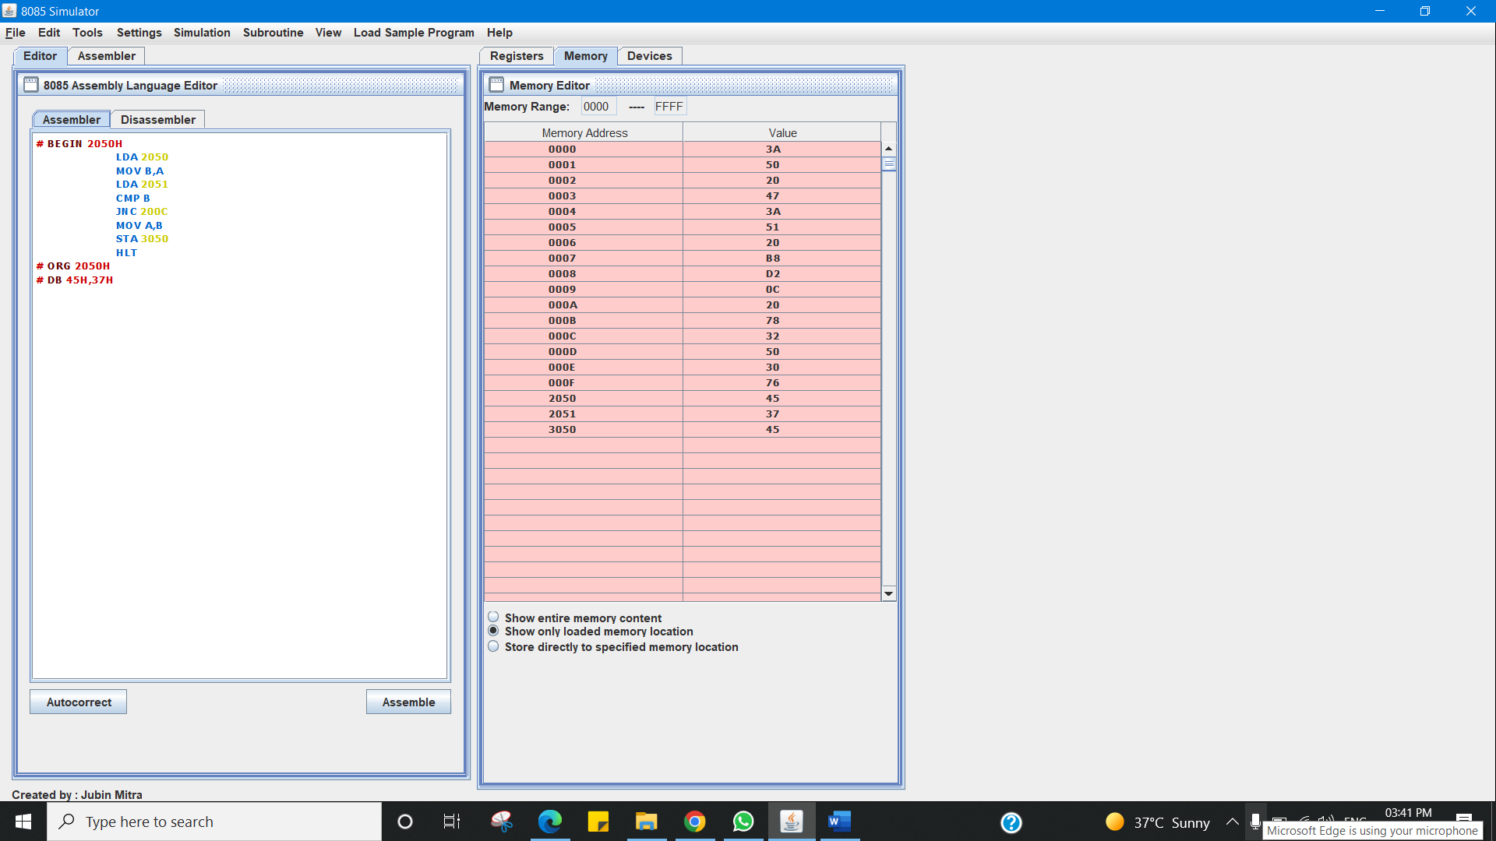

**Learning outcomes (What I have learnt):**

1. Working of microprocessors.

2. Learn about 8085 simulator.

3. Finding the smaller out of two numbers.

4. Finding the larger out of two numbers.

**Evaluation Grid (To be created as per the SOP and Assessment guidelines by the faculty):**

|  |  |  |  |
| --- | --- | --- | --- |
| Sr. No. | Parameters | Marks Obtained | Maximum Marks |
| 1. |  |  |  |
| 2. |  |  |  |
| 3. |  |  |  |
|  |  |  |  |